Enter Title Here Using 14-Point Times New Roman Font and Allowing the Title to Run Over to the Next Line If Needed
Author A. Name¹, Author B. Name¹, Author C. Name², and Author D. Name¹
1Institution One Name, Street Address, City, State/Province Zip/Postal Code, Country 2Institution Two Name, Street Address, City, State/Province Zip/Postal Code, Country Email: email@email.com / Phone: (012)-345-6789

Overview
Use the remainder of this page for your abstract text. This must be in Times New Roman font of at least 10pt. Either single or double column format is acceptable, and this template supports both layouts (see the readme at the top of the LaTeX file). You are encouraged to use headings (in bold) for different sections such as: Introduction, Experimental Process, Device Results, and Significance or Conclusion. The use of these (or any other) headings is not required, but could be used to bring greater clarity to your abstract. Remember that the abstract must clearly communicate the new and significant results that have been obtained. What makes the reported work important? Why are these results significant compared to previous related work?

Margins
The margins for all DRC abstracts must be 1” (2.5 cm) all around, without exception! This is true for both the Text page (this page) as well as the Figures page (the next page).

Figures
The second page of a DRC abstract is to be used only for figures. As explained below, all references should be at the bottom of this Text page. A few examples of figure styles are given on the next page (eg Fig. 1, Fig. 3). Ultimately, authors can arrange and style their figures on the 2nd page however they would like as long as the following guidelines are met:
- Figures and captions must be kept to within the 1” (2.5 cm) page margins.
- All figures should have a corresponding caption.
- Font for the figure captions must be kept to Times New Roman 10 pt.
- All figures should be numbered (e.g., Fig. 1, Fig. 2, etc.) and referred to at some point in the Text (on this page).
- Figures with multiple parts should have each part distinctly labeled with ‘a)’, ‘b)’, ‘c)’, etc.

References
All references should be on the bottom of this page, eg [1]. It is recommended that the references follow the format used for IEEE Electron Device Letters (http://eds.ieee.org/edl.html), but other formats are accepted, including more concise versions that use et al., only give the first page for an article, and so on. The font for the references must be Times New Roman with at least 9 pt. size and they may also be assembled in a column-like fashion as shown below to save space, eg [2, 3]. Be sure that you do not change the page margins to try and create more space for references! Also, references should not be placed on the Figures page.

Submission
For submission, the abstract should be saved as a PDF file (or converted to PDF in some fashion). Please do not insert page numbers or any other text in the footer or header of the file.

- A. D. Franklin et al., IEEE-EDL, vol. 33, p. 17, (2012).
- R. Yan et al., Nano Lett., vol. 15, p. 5791, (2015).
- R. Salas et al., Appl. Phys. Lett., vol. 106, p. 081103, (2015).
- S. -J. Han et al., IEDM Tech. Dig., p. 2.2.1, (2011).

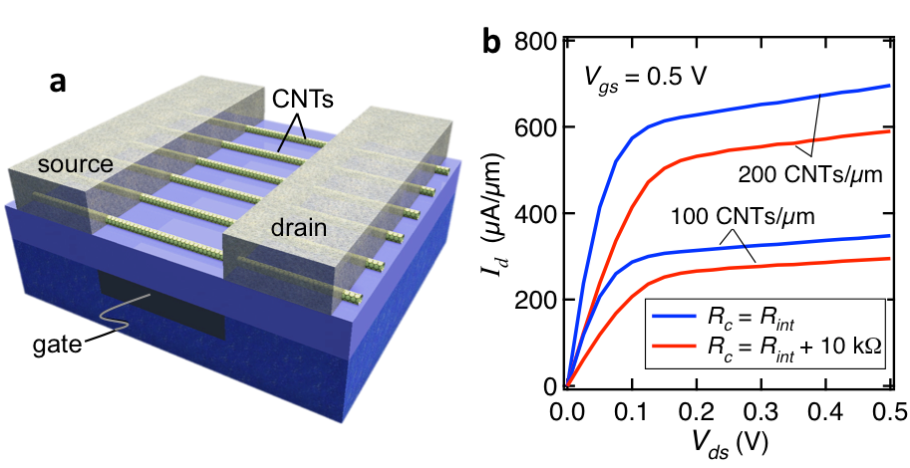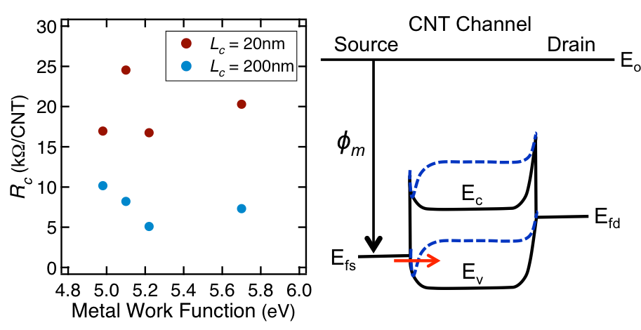

Fig. 1: This is an example figure to show one method for creating the figures on this page. Two minipages just smaller than half the pagewidth are placed in one “figure” environment. Each minipage holds one graphic/caption, and the two are horizontally stacked.
Fig. 2: Of course, seeing as this is LaTeX, there are many different methods you could use for placing/aligning fig- ures if you want to get more precise. For starters, check out http://tex.stackexchange.com/a/148445/39047 or https://en.wikibooks.org/wiki/LaTeX/Floats,_Figures_ and_Captions.

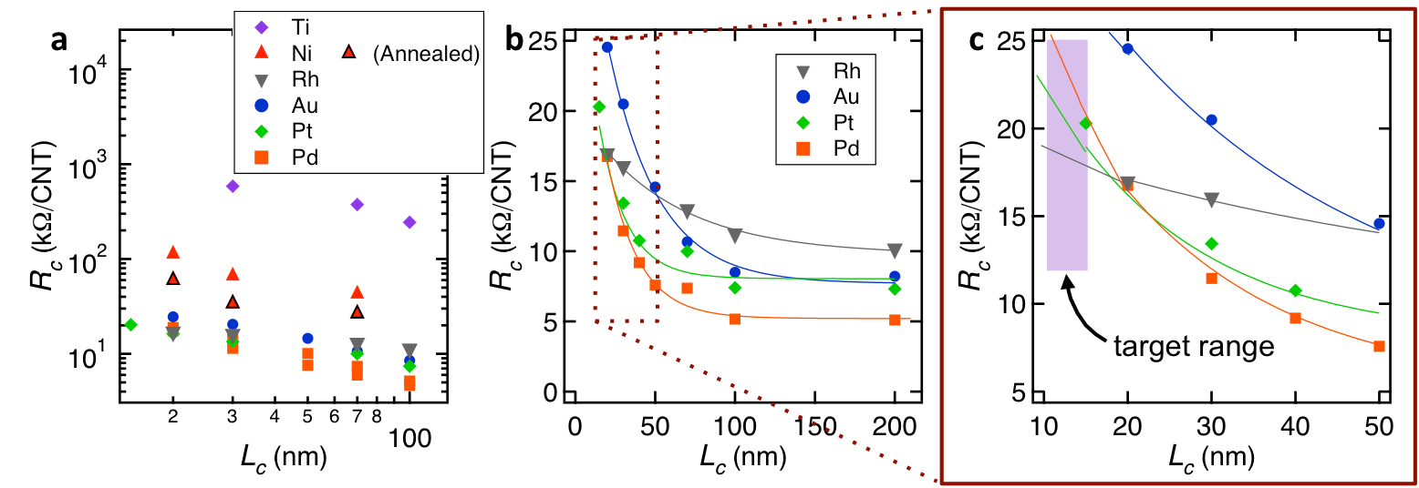

Fig. 3: Of course, you don’t have to get fancy. Here’s a basic figure just spanning the width of the page. But do notice the individually labelled subparts, and the fact that there is no more text on this page beyond captions.

